Network Packet Sniffer
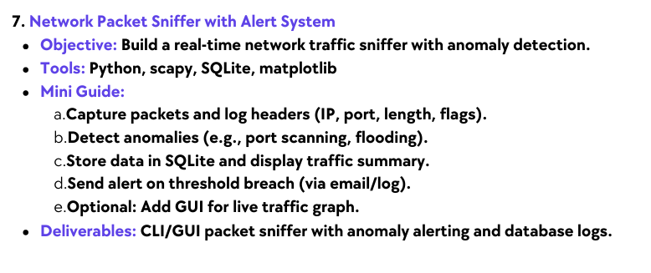
Elevate Labs Internship Report
Name: Soham Dutta Email: sohamdutta.haldia@gmail.com

Contents
Sl. | Name | Pg. No.
1 | Project Overview | 2
2 | Database Script | 2
3 | Packet logging Script | 3
4 | Packet analyze Script | 3
5 | Packet alert Script | 3
6 | Network sniffer Script | 3
7 | Visualize DB graphs | 3
8 | Results & Outputs | 3
9 | Conclusion | 5

2. Project Overview
Title: Network Packet Sniffer

Purpose
This project, titled ‘Network Packet Sniffer’, focuses on real-time monitoring of network traffic to detect suspicious activities. The system captures packets flowing through a network interface, stores them in a database, and raises alerts if abnormal patterns are detected. It also provides data visualization for better analysis of network behavior.

Work Flow
- Packet Capture (Scapy): sniffing live traffic from network interface.
- Protocol Identification: logging TCP, UDP, ICMP.
- Alert Logic: raising alerts when packet counts exceed threshold.
- Database Storage (SQLite): saving both packets and alerts for analysis.
- Modular Code Structure: separate scripts for logging, alerts, and analysis.
- Error Handling /Exit: DB safely closes on Ctrl + C.

Key Features
• Monitors your network in real time.
• Captures packets (source IP, destination IP, protocol, port, size).
• Detects suspicious behavior (like too many packets from one IP means possible DoS attack, or sequential port scans).
• Logs all details in a SQLite database and sends an alert when something suspicious happens.
• Provide analytical and visual insights using Pandas and Matplotlib.

Tools and Tech-stacks Used
• Python 3
• Scapy - for packet sniffing and analysis
• SQLite3 - for database storage
• Pandas - for data analysis
• Matplotlib - for visualization

2. Database Script (trafficdb.py)
This script is responsible for creating and managing the project’s SQLite database (trafficdb).
It defines tables to store captured packet data and network alerts. Each packet record includes source IP, destination IP, protocol, packet size, and timestamp.
The alerts table stores information about IPs that exceed the predefined traffic threshold. It ensures data persistence so that packets and alerts can later be analyzed or visualized.
There is also clear_db.py script which is designed to clear all existing records from the project’s database (traffic.db). It deletes entries from both the packets and alerts tables, and also resets their auto-increment counters to start fresh.
This helps maintain a clean testing environment whenever the network sniffer is re-run for new experiments or demonstrations and restarting the monitoring cycle.

3. Packet logging Script (packet_logger.py)
This script captures live network packets using the Scapy library and logs essential details into the database.
It extracts information such as source and destination IP addresses, protocol number, packet size, and timestamp.
The main goal of this module is to store every captured packet systematically for further analysis.

4. Packet analyze Script (packet_analyze.py)
This script focuses on analyzing the stored packet data from the database. Using SQL queries and Pandas, it provides insights such as the number of packets by protocol and the top most active IP addresses.
This module helps understand traffic patterns and detect which IPs are communicating most frequently.

5. Packet alert Script (packet_alert.py)
The alert script introduces a detection system that monitors network behavior for anomalies.
It tracks the number of packets sent by each source IP and triggers an alert when the count exceeds a specified threshold (e.g, 15 or 50 packets).
When suspicious activity is detected, an alert message is displayed and recorded in the database for reference.

6. Network sniffer Script (network_sniffer.py)
This is the main execution script that combines all other modules database handling, packet logging, and alerting into one cohesive system. It continuously monitors network packets and integrates alert logic to detect unusual activity. This script effectively acts as the project’s entry point and real-time monitoring tool.

7. Visualize DB graphs (visualize_traffic.py)
This script is used for visualizing stored network data through graphs. Using Matplotlib and Pandas, it creates clear graphical representations of protocol distribution and top active IPs.
It transforms raw data into easy to understand visuals, which helps identify traffic trends and network behavior at a glance.

8. Results & Outputs
Network Sniffer script: Sniffing starts and real time packets are being captured with alert showing in case an ip sending more then threshold limit. CTRL-C and it stops and pushes the data on the Trafficdb Database.
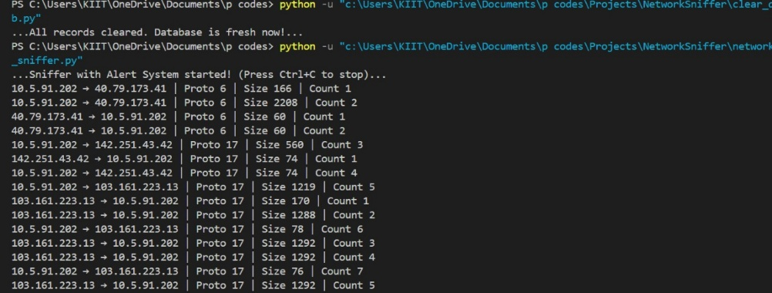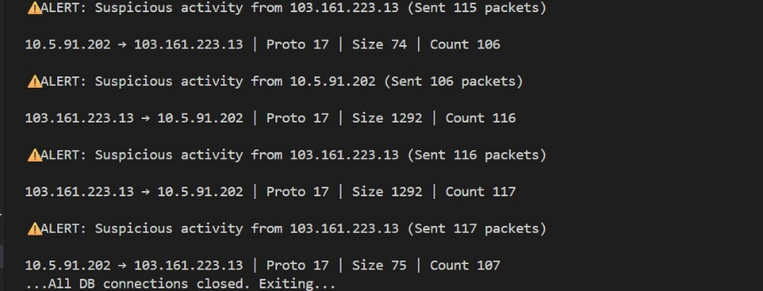
Packet Analyze script: It analyzes the packets and shows the count of TCP,UDP,ICMP and the respective packets.
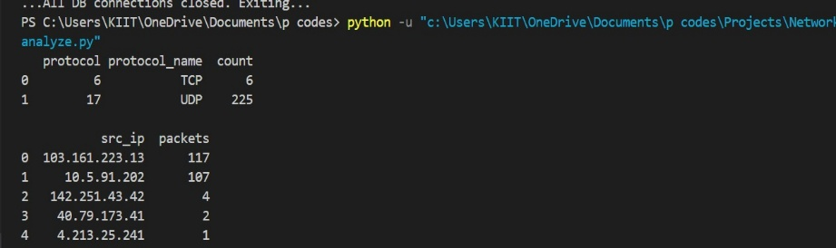

Trafficdb Database:
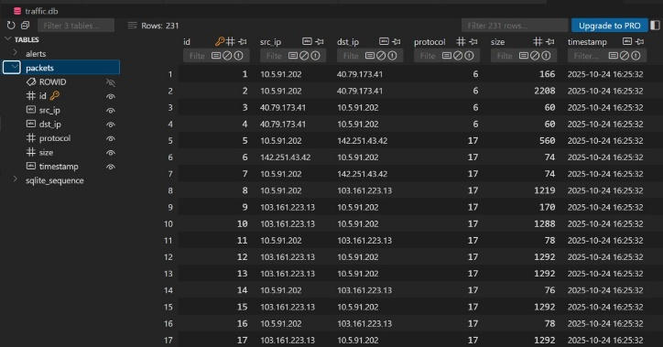 | 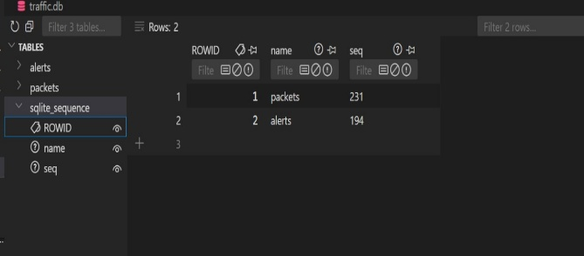
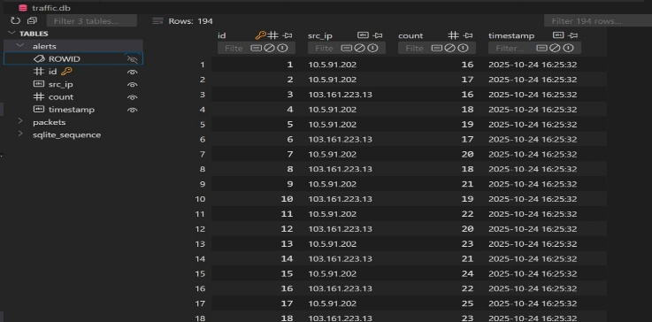 | These are the SQLite database consisting of packets and the alerts occurred with the sequence count. We can filter out the specific ip and the packets needed.

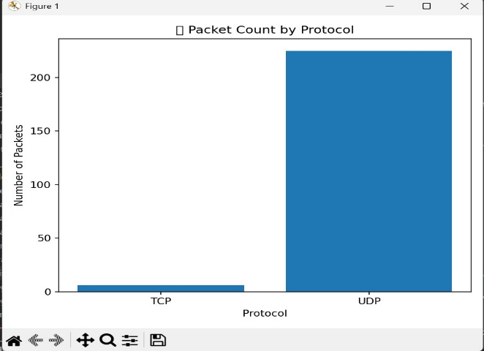 | 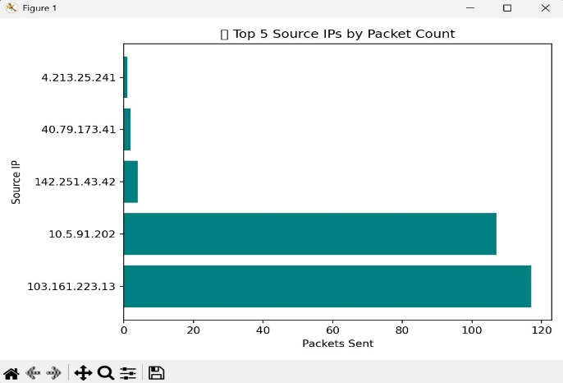
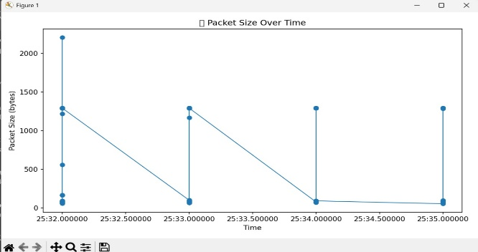 | Visually represented the active ip and packets by matplotlib.

9. Conclusion
The Network Packet Sniffer with Alert and Visualization successfully demonstrates how network traffic can be captured, analyzed, and monitored using Python. By integrating Scapy for packet sniffing, SQLite for data storage, and Matplotlib for visualization, the project provides a complete end to end solution for basic network monitoring.
The system not only records real time packet data but also detects abnormal traffic activity through its alert mechanism. The inclusion of data visualization further aids in understanding traffic patterns and identifying frequently active IPs or protocols.
It lays a strong foundation for building more advanced systems like Intrusion Detection Systems (IDS) or network dashboards that can monitor, visualize, and protect networks in real time.

